KLA (KLAC)
Too far outside sweet spot
However, understanding KLA is essential for evaluating the competitive positioning of other companies.
Category: Inspection & Metrology (Front-End)
Est. Price Per Unit: $5M - $10M+ per tool

What They Do

Product 101 and Where They Fit into the AI Stack
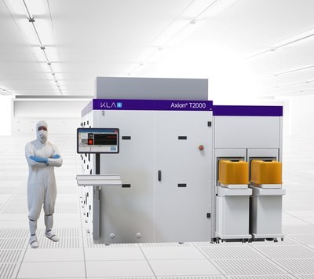
KLA is the dominant player in semiconductor process control and yield management—the "MRI for chips." They have ~55-65% of the overall inspection/metrology market and 75-80% in patterned wafer inspection.
Metrology: film thickness, critical dimension, overlay accuracy
The core problem: as chips shrink and complexity grows, microscopic defects become yield killers. A single particle can ruin an expensive AI chip. KLA detects defects during manufacturing so fabs can fix process issues before ruining wafer lots.
They provide end-to-end process control across the fab:
Reticle inspection: checking the photomask before it patterns thousands of wafers
Patterned wafer inspection: optical systems (2900 Series, Puma) for high-speed full-wafer coverage
E-beam inspection (eSL10): nanometer-scale precision for electrical defects invisible to optical. KLA gained 700 bps of e-beam share in 2024—revenues doubled YoY
Advanced packaging revenue surged from ~$500M in 2024 to projected $925M+ in 2025 (~85% growth). This is where they intersect with Camtek's territory.

Alignment with Overall Thesis
As AI chips become more expensive, the cost of a defective chip skyrockets. KLA tools are no-regrets purchases for fabs maximizing yield.
Sub-7nm processes, 3D architectures, and advanced packaging all increase defect sensitivity. More process steps = more inspection = more KLA revenue.
KLA benefits from the same HBM/memory stacking trends as Camtek, just at an earlier stage of the fab.

Business Model, Customers
$5M-$10M+ per tool (significantly more expensive than Camtek's ~$1M systems).
Yield management purchasing dynamic—bought when defect rates are too high. Scales with complexity.
Customers are leading-edge logic fabs (TSMC, Intel, Samsung) and memory IDMs. Tool of record at virtually every advanced fab.
~30% recurring revenue from services and upgrades.

Comments on Team
Founded in 1975; founder retired but is Chairman Emeritus.
CEO Rick Wallace has been with KLA since 1988.
Professional management, not founder-led. Execution-focused with strong capital return discipline.

Early View of Moat Hypothesis
Algorithms are the moat. High resolution isn't enough—you need algorithms that separate defects from noise. KLA's AI-
augmented inspection is decades of data and iteration. Hard to replicate.
Fabs build process recipes around KLA tools. Switching costs are enormous.
~$1B+/year on R&D. Smaller competitors can't match portfolio breadth.

Why They're Interesting, and Why Now
KLA is the benchmark against which smaller players (Camtek, Onto) are measured. Understanding KLA helps us
understand where smaller players can win.
Bull case: AI complexity increases, yield becomes more critical, advanced packaging grows, e-beam gains continue.

Key Risks
Priced for perfection. Any miss hurts.
China exposure—geopolitical restrictions on equipment sales.
Camtek, Onto gaining share in packaging inspection where KLA is pushing to expand.

Gaps in Understanding / Key Questions
How much of advanced packaging growth is greenfield vs. taking share from Camtek/Onto?
Is e-beam inspection becoming commoditized or is KLA's lead durable?
What's the actual overlap with Camtek in HBM? Complementary or competitive?

Select Financial Graphs

R1: Total Revenue & YoY Growth
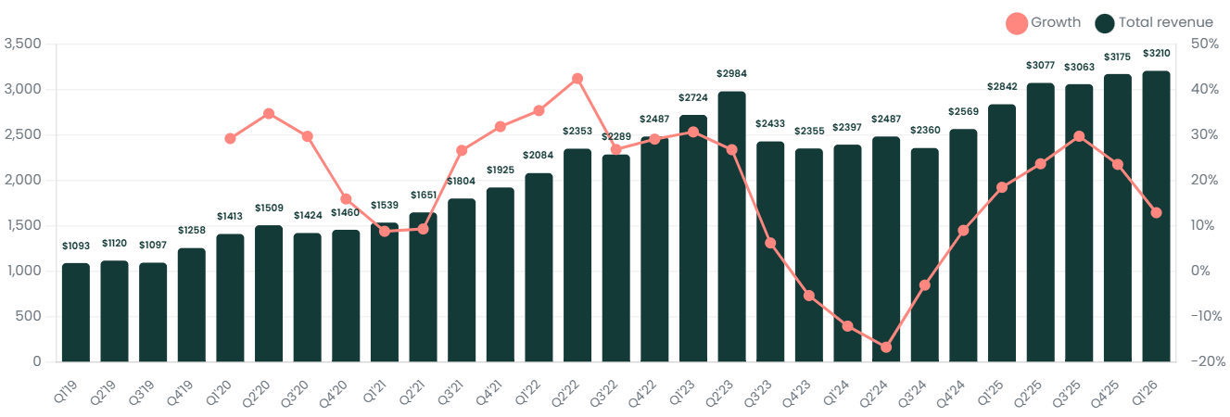

I1: Inventory Turns
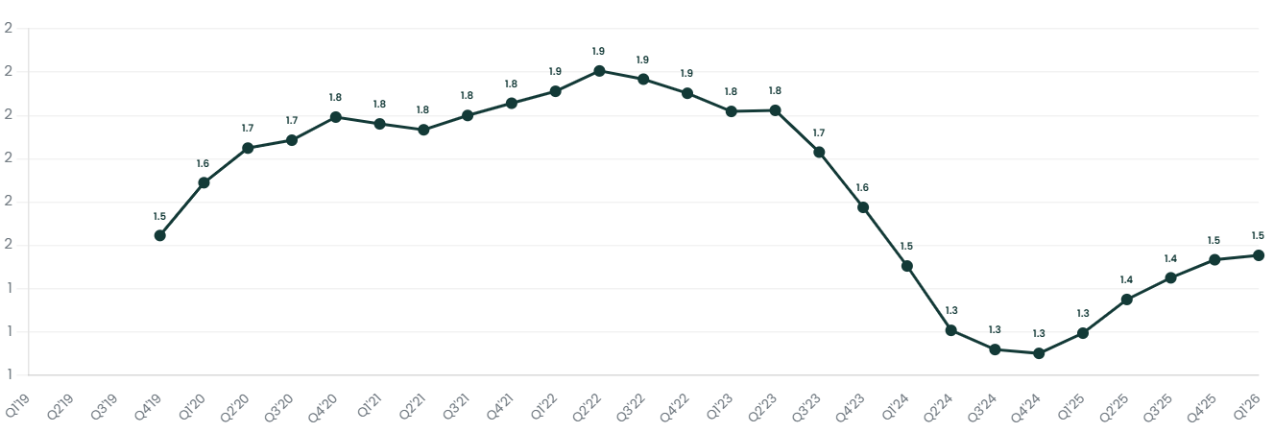

P3: EBIT Margin
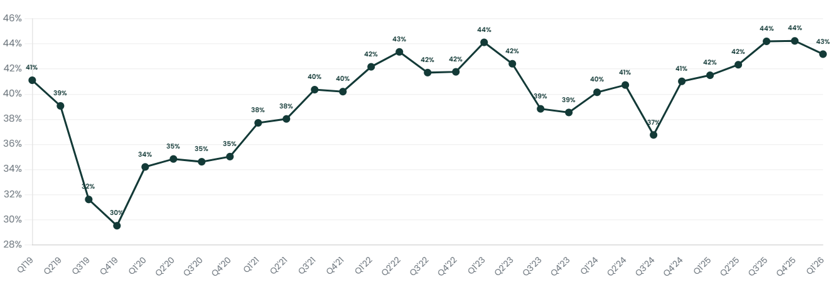

S5: Revenue by Geography
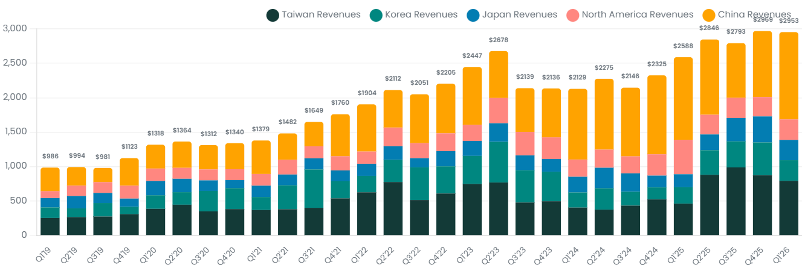

V1: EV/Sales NTM
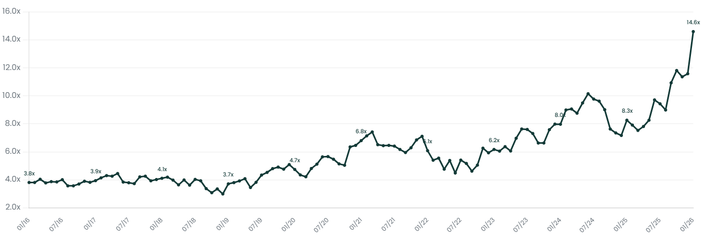

Patent Analysis

Inspection & Metrology Dominance
KLA's patent volume dwarfs Camtek and Onto across all inspection categories. This is the R&D moat in action—smaller players can't match the breadth.
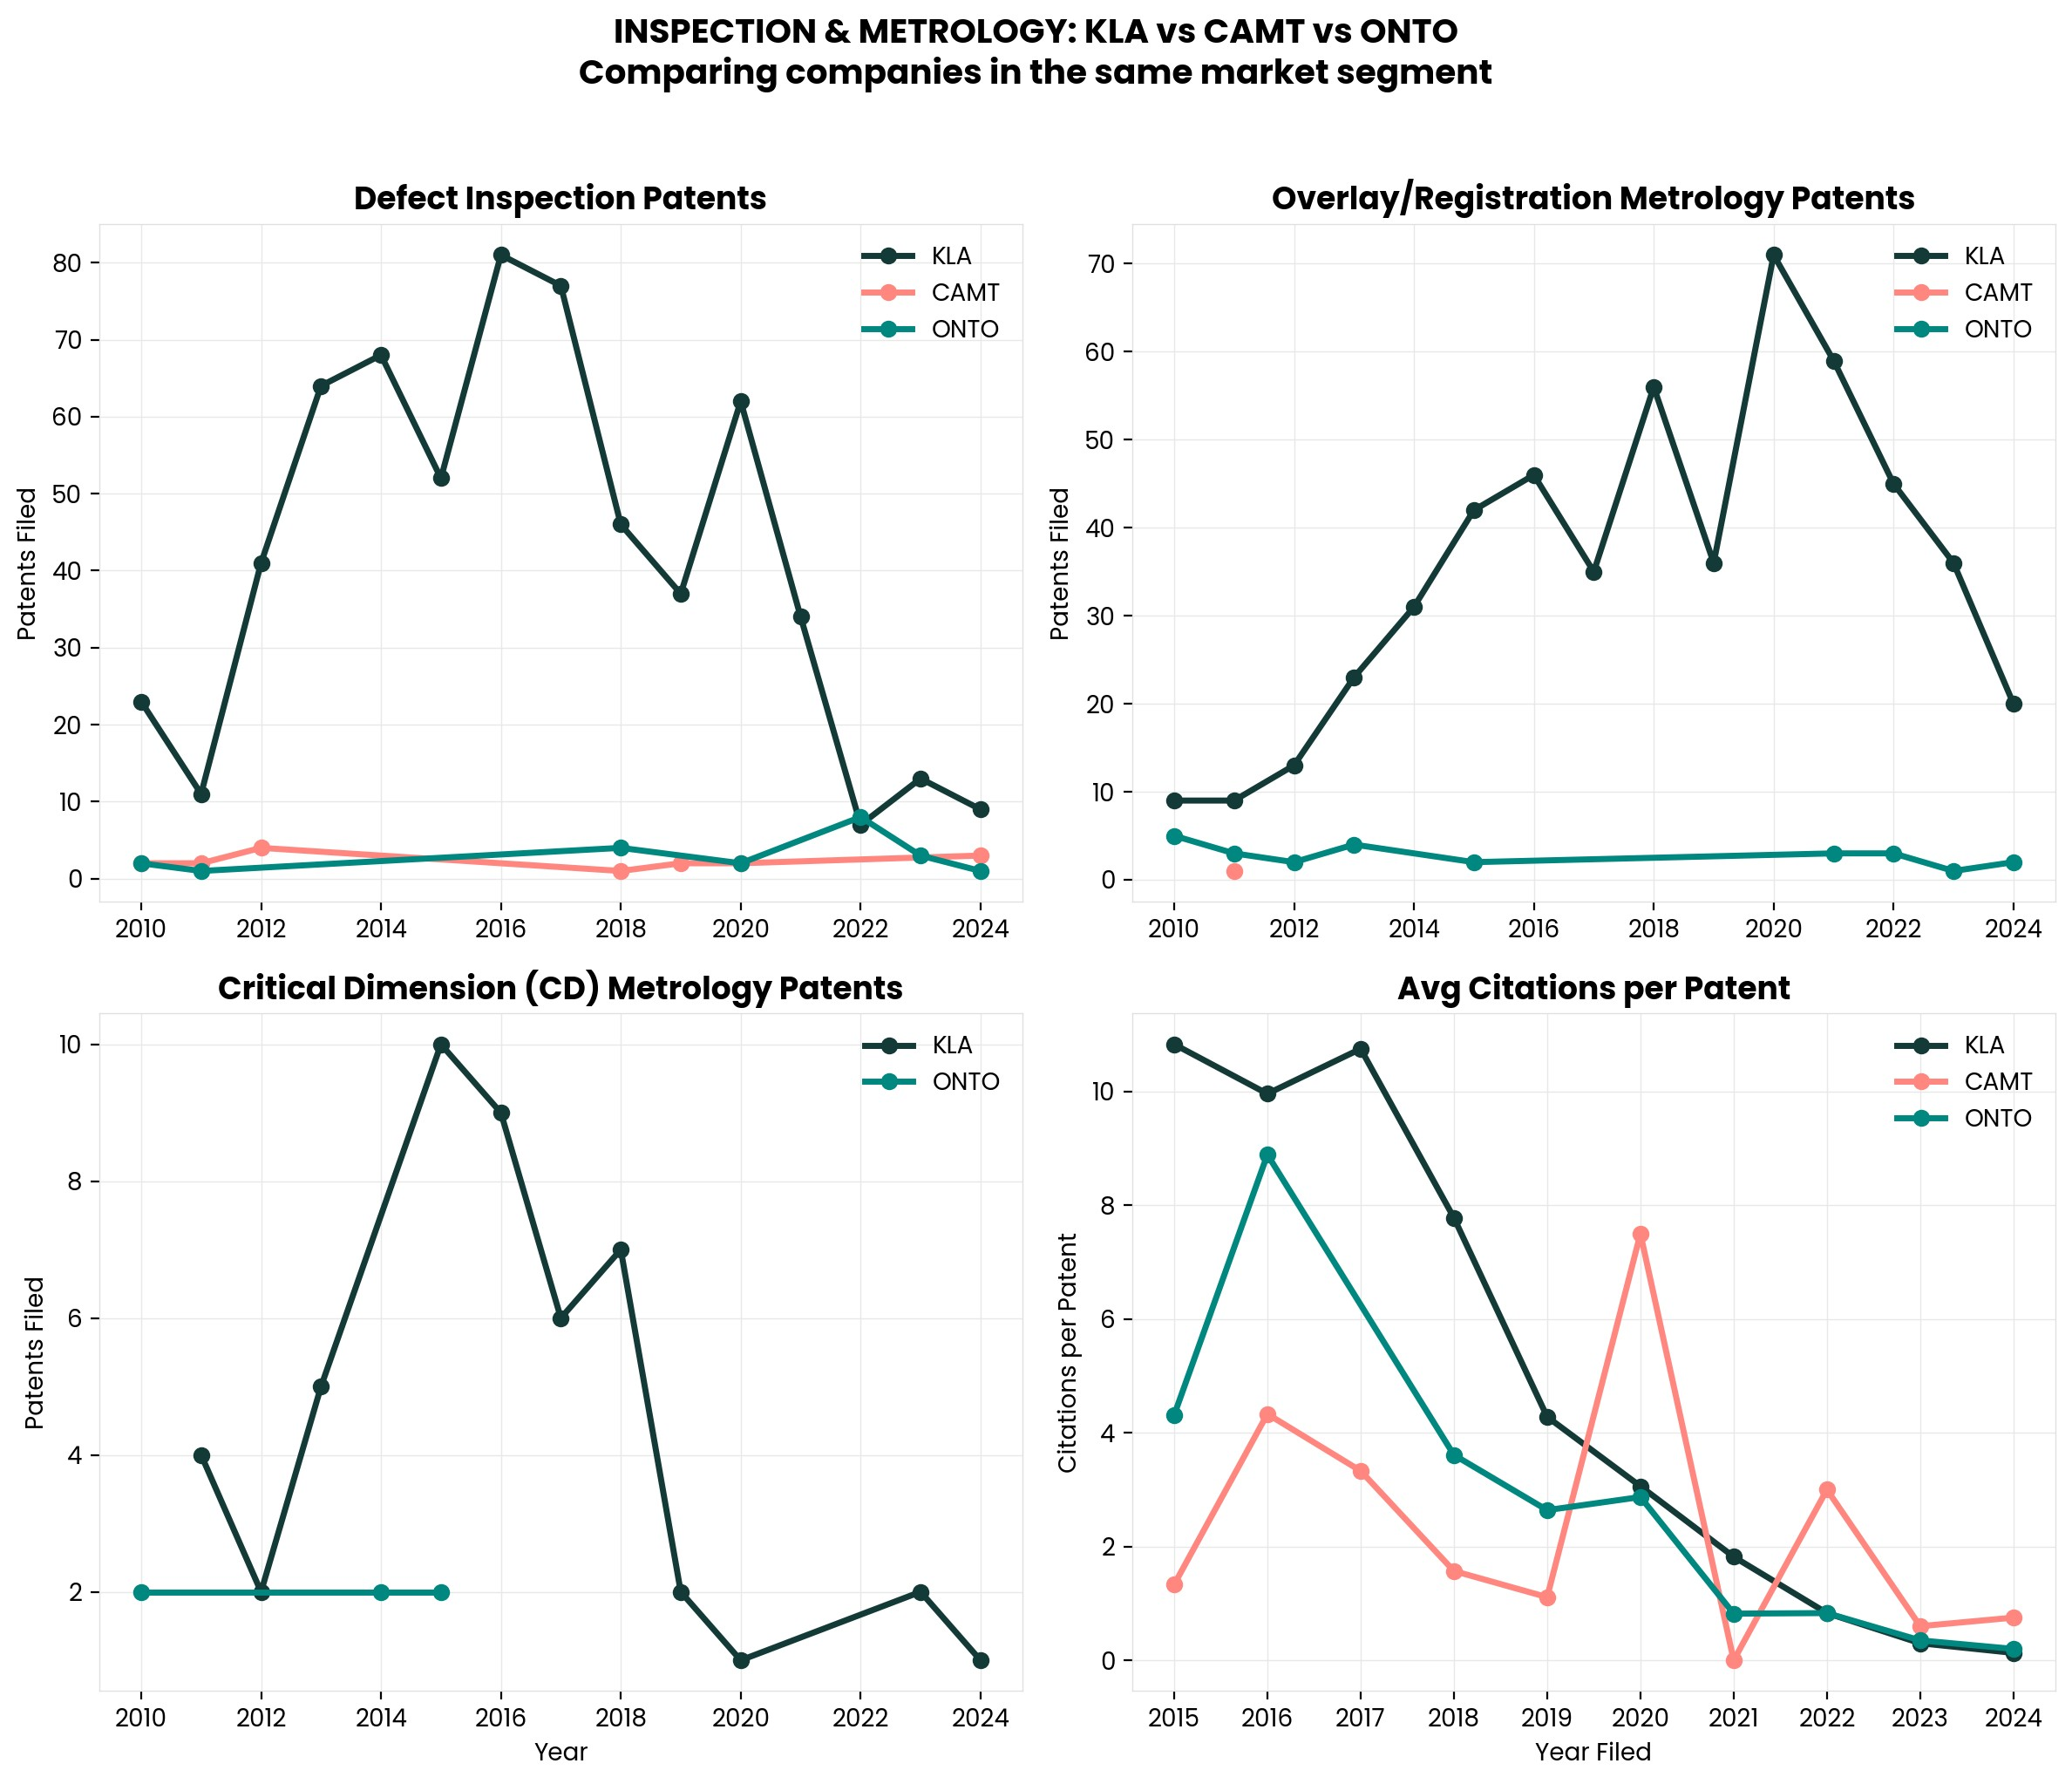

Interesting Topics to Read
KLA vs. Camtek vs. Onto Innovation competitive positioning
E-beam inspection vs. optical inspection trade-offs
Yield learning and process control in advanced nodes
KLA's AI-augmented defect classification (SMARTs™)
Advanced packaging inspection market dynamics

